**Assignment – 11**

**Problem Statement:**

**Build scaling plans in AWS that balance the load on different EC2 instances.**

1. Go to EC2 then in Instances click on Launch Templates.

1. Click on Create launch template.

1. Give Launch template name and then click on checkbox for Auto Scaling guidance.

1. In Quick Start select Ubuntu.

1. Select Instance type – either t2.micro or t3.micro. Create new key pair.

1. Select existing security group.

1. Now go to Advanced details and then in User data write given statements and then Create launch template.

#!/bin/bash

apt -get update

apt -get install -y nginx

systemctl start nginx

systemctl enable nginx

apt -get install -y git

curl -SL https://deb.nodesource.com/setup_16.x|sudo -E bash -

apt -get install -y nodejs

git clone https://github.com/UnderDevelopment10/new-repo1.git

cd new-repo1

npm install

node index.js

1. After creating Launch template, click on Auto Scaling Groups in left pane.

Click on Create Auto Scaling group.

1. Give Auto scaling group name and then select your recently launched template. Then click on Next.

1. Select availability zones and subnets then click on Next.

1. Click on Attach to a new load balancer.

1. Select Application Load Balancer as load balancer type and Internet-facing as Load balancer scheme.

1. Select port no. 4000 for HTTP and select New target group name.

1. Now turn on Elastic load balancing health check and in health check grace period give 240 seconds. Then click on Next.

1. Select 2 in Desired capacity in group size and in Scaling 2 as Min desired capacity and 3 as Max desired capacity.

1. Next in Automatic scaling select Target tracking scaling policy and give 240 in Instance warmup.

1. Then click on Next, then again next.

1. Now click on Create Auto Scaling group.

1. Come back to EC2 dashboard and go to Instance and here you can see 2 instances running as minimum capacity 2 is chosen.

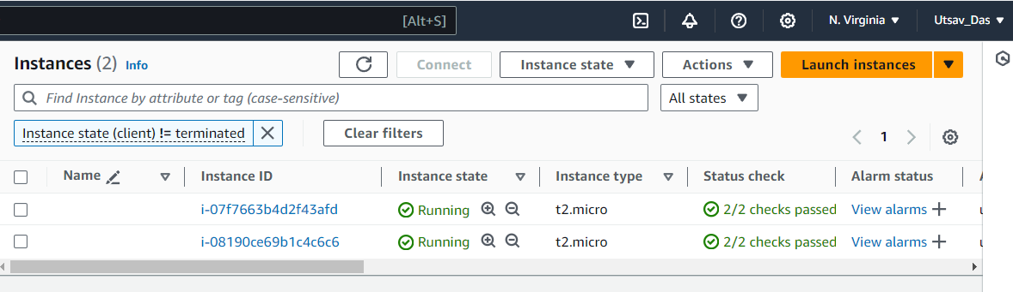

1. Click on any instance and then copy public IPv4 address.
2. Open Bitvise SSH client and then paste that public IPv4 address and then in client key manager import the generated key and then Login.

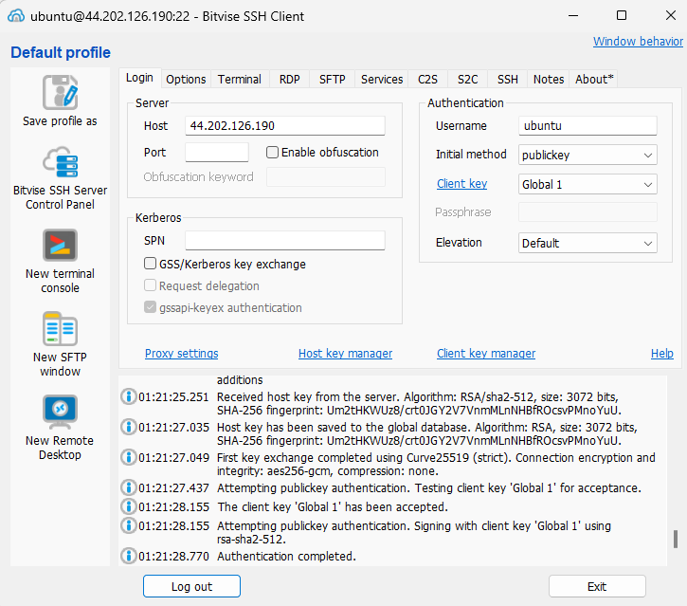

1. Open New terminal console and then write command 'sudo nano infi.sh'. A new .sh file will be created. Now write this code to run an infinite loop.

!/bin/bash

while(true)

do

echo"Inside Loop"

done

1. Then do Ctrl+X then Y then click Enter. And write command 'sudo chmod 777 infy.sh' to provide all permissions to file and then to run give 'sh infy.sh'.

1. Here we can see infinite loop running.

1. Go back to instances and then select both instances and then in bottom pane, go to CPU utilization and select Enlarge.

1. The graph displays CPU utilization for both instances. When CPU utilization for one instance is very high, then another instance will be created as we have set maximum capacity to 3.
2. Finally in Instances, we can see another new instance is created.

